**Computer Network Lab**

Name: Harshavardhan Anil Bamane

Class: SY BTech CSE

PRN: 22510112

Batch: S-7

Address Resolution Protocol

1) Write down the contents of your computer’s ARP cache. What is the meaning of each column value

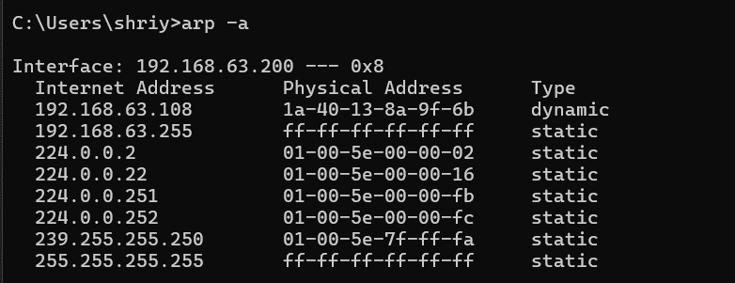

2) What are the hexadecimal values for the source and destination addresses in the Ethernet frame containing the ARP request message?

=> Hexadecimal values for following in the Ethernet frame containing the ARP request message is

Source Address: 3e:93:ba:05:5f:0c

Destination Address: a0:29:42:9f:be:60



3) Give the hexadecimal value for the two-byte Ethernet Frame type field. What upper layer protocol does this correspond to?

=> Hexa-decimal value for the two-byte Ethernet Frame type field is 0x0806 it corresponds to ARP protocol.



4a) How many bytes from the very beginning of the Ethernet frame does the ARP opcode field begin?

=> After 20 bytes from very beginning of the Ethernet frame ARP opcode field begin i.e. 00 01 used for request

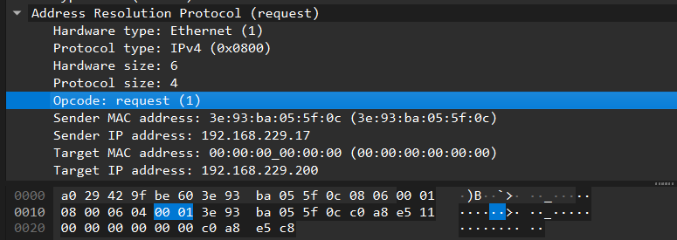

4b) What is the value of the opcode field within the ARP-payload part of the Ethernet frame in which an ARP request is made?

=> The value of opcode field within ARP payload part is 00 01 used for making request.

4c) Does the ARP message contain the IP address of the sender?

=> Yes it contains IP Address of Sender

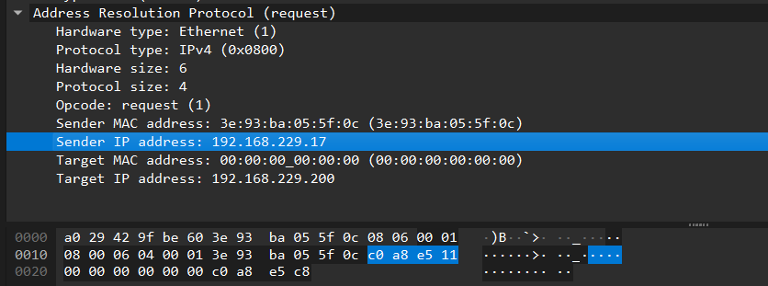

4d) Where in the ARP request does the “question” appear – the Ethernet address of the machine whose corresponding IP address is being queried?

=> Question is made by keeping target MAC address field as 00:00:00:00:00:00 and it appears after sender IP Address.

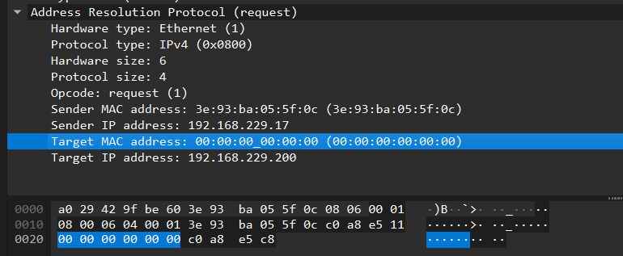

5a) How many bytes from the very beginning of the Ethernet frame does the ARP opcode field begin?

=> After 20 bytes from very beginning of the Ethernet frame ARP opcode field begin i.e. 00 02 used for reply

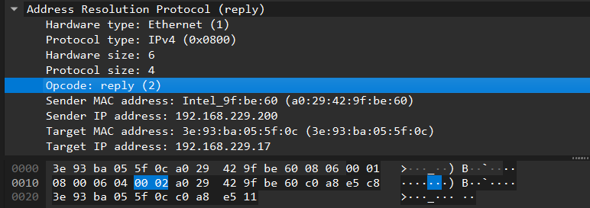

5b) What is the value of the opcode field within the ARP-payload part of the Ethernet frame in which an ARP response is made?

=> The value of opcode field within ARP payload part is 00 02 used for making response.

5c) Where in the ARP message does the “answer” to the earlier ARP request appear – the IP address of the machine having the Ethernet address whose corresponding IP address is being queried?

=> Answer to the earlier ARP request appear after Sender IP Address field in ARP frame.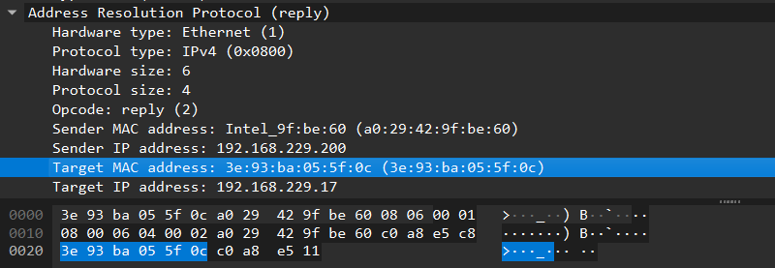

6) What are the hexadecimal values for the source and destination addresses in the Ethernet frame containing the ARP reply message?

